INFOSYS SPRINGBOARD VIRTUAL INTERNSHIP
MODULE-2
NAME: N.Rachana
PROJECT NAME: HotelRevAI AI Driven Revenue Analysis for Hotels_Batch -13
1. Objective
The goal of this module is to break down summary booking data into a daily level granular format. This allows for the analysis of daily revenue trends, occupancy rates per specific date, and the calculation of daily KPIs.
2. Creation of Excel Tables:
  - Creation of Duration_Details Table:
The Bookings table containing all booking details was used as the base dataset. From this table, selected columns such as BookingID, DateID, RoomID, CustomerID, CheckInDate, CheckOutDate, NightsStayed, and Total Price were extracted to create a new table named Duration_Details.
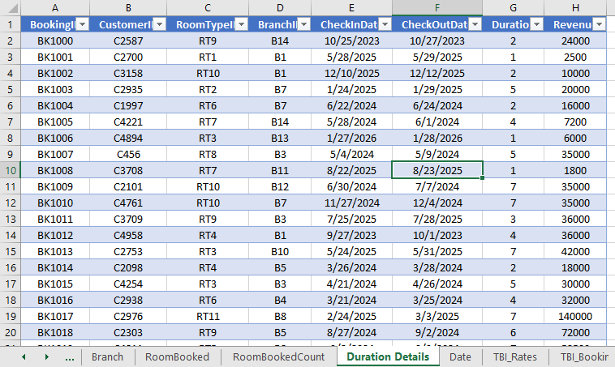
The table was selected and loaded into Power Query using Data Tab → Get & Transform Data → From Table/Range to begin data transformation.

2.1.1 Add Custom Column
In Power Query Editor, a custom column named StayDate was created using Add Column → Custom Column. The M-code formula generates a list of dates between the check-in and check-out dates for each booking
Formula:
if [CheckInDate] <> null and [CheckOutDate] <> null then
List.Dates(Date.From([CheckInDate]), Duration.Days([CheckOutDate] - [CheckInDate]), #duration(1,0,0,0))
else
null
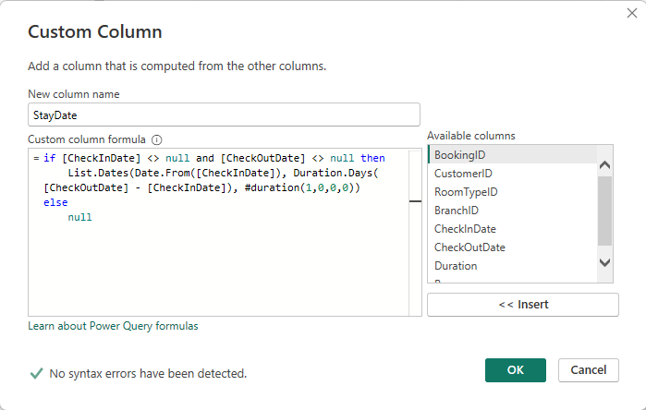
2.1.2 Expand Rows:
- Click the Expand arrows (two diverging arrows) next to the new StayDate column header.
- Select "Expand to New Rows".
- Result: Each booking is now duplicated for every day the guest stayed.
2.1.3 Group By (Occupancy Count):
In the Transform tab, the Group By option was used to group the data by StayDate. A new column named Room Booked was created by counting the number of rows for each date.
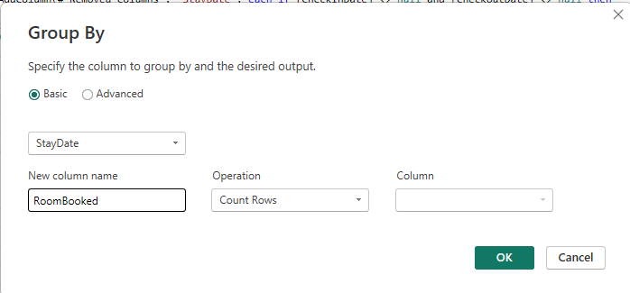
2.1.4 Load Data:
The transformed data was loaded into a new worksheet using Home → Close & Load To, and the sheet was renamed as Rooms Booked. 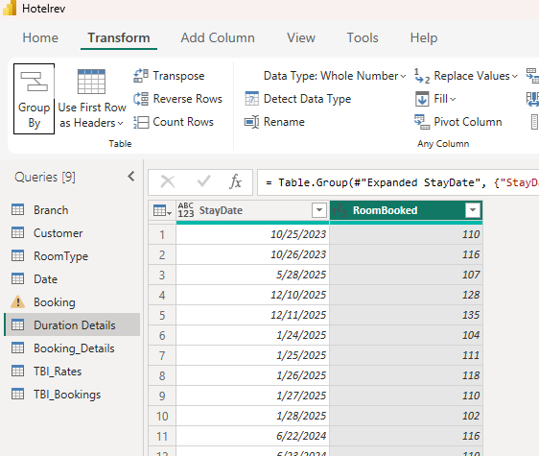
  - Creating "Yearly and Monthly Date" (Pivot Table)
This sheet is used for a quick summary view of room bookings aggregated by time.
- A PivotTable was inserted from the Rooms Booked table.
- Years, Months, and StayDate were added to the Rows section.
- Room Booked was added to the Values section with Sum aggregation.
- The worksheet was renamed Yearly and Monthly Date.
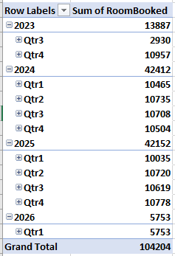
  - Creating "Master Data" Table
- Create Table: Create a new sheet named "Master Data".
- Columns & Formulas:

- Month: Enter Month Starts from 01-Jan-2022 to 31-Dec-2024.
- Day Count =DAY(EOMONTH(A2,0))
- Room Available =B2*150
- Rooms Sold: Take Data from Yearly and Monthly Date table.
- Occupancy Rate =(D2/C2)*100

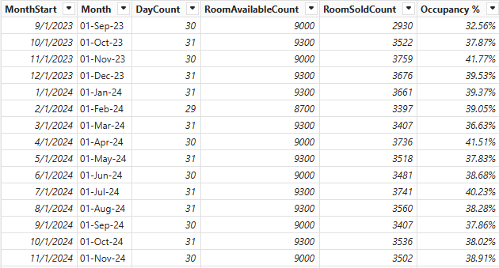
2.4 Creating Booking_Details Table
- Create a new Sheet named “Booking_Details”.
- Columns and Formulas:
- StayDate and Room Booked: Copy from Rooms Booked Table.
- Month Year =TEXT(A2, "mmm yyyy")
- Month Start =DATE(YEAR(A2), MONTH(A2), 1)
- Year =YEAR(A2)
- Month =MONTH(A2)
- Season
=IF(OR(MONTH(A2)=12,MONTH(A2)<=2),"Winter",
IF(MONTH(A2)<=5,"Spring",
IF(MONTH(A2)<=8,"Summer","Autumn")))
- Weekday =TEXT(A2,"dddd")
- WeekNum =WEEKNUM(A2,1)
- WeekStart =A2-WEEKDAY(A2)+1
- YearWeek=YEAR(A1+3-WEEKDAY(A1,3)) & "-W" & TEXT(ISOWEEKNUM(A1), "00")
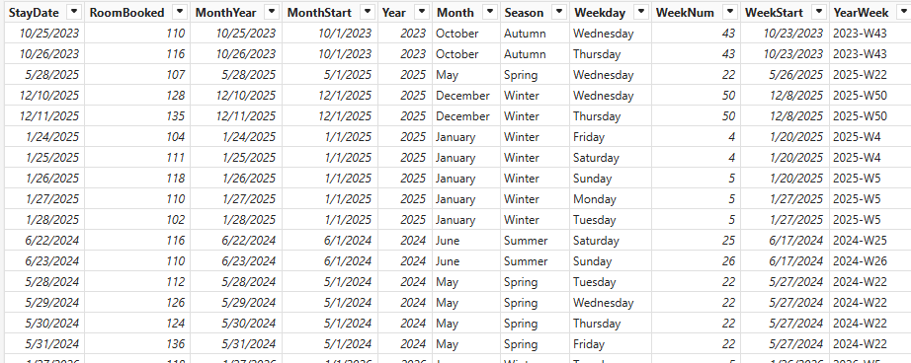
2.5 Creating TblRates Table
Create a new sheet named TblRates with a table containing RoomID and Price as columns
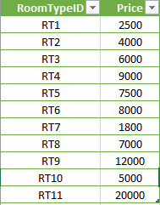

2.6 Creating TblBookings Table
- Create a new sheet.
- Create a Table with Columns BookingID, CustomerID, BranchID, RoomID, CheckInDate, CheckOutDate, NightsStayed, StayDate from Booking_Details Table
- Go to Data →Get Data →Combine Queries → Merge.
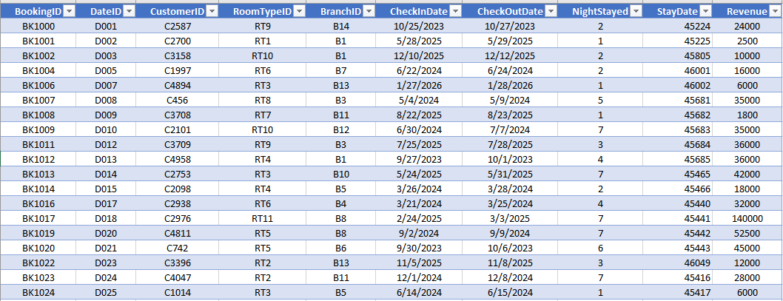

2.7 Creating "Tbl_Calculation" (Final KPI Table)
This is the consolidated table used for final calculations using the derived data.
- Create Sheet: Name it "Tbl_Calculation".
- Columns & Formulas:
- StayDate and Room Booked Count : Copy from Rooms Booked Table.
- Total Revenue =SUMIFS(TblBookings!J:J, TblBookings!I:I, Tbl_Calculation!A2)
- Total Rooms = 150
- Occupancy % =B2/D2*100
- ADR =C2/B2 (DataType : Currency -> English (India))
- RevPAR =(F2 * E2)/100
- Season
=IF(OR(MONTH(A2)=12,MONTH(A2)<=2),"Winter",
IF(MONTH(A2)<=5,"Spring",
IF(MONTH(A2)<=8,"Summer","Autumn")))

- Weekday =TEXT(A2,"dddd")
- Week =WEEKNUM(A2)
- MonthStart =DATE(YEAR(A2), MONTH(A2), 1)
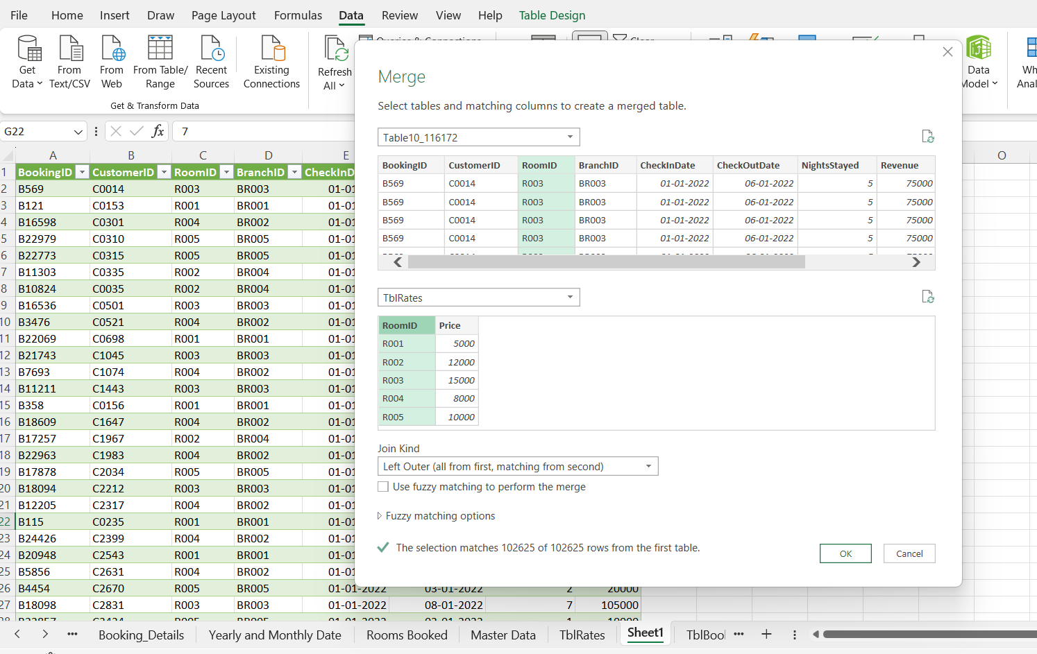
- Month =TEXT(A2,"MMMM")
- Quarter ="Q" & ROUNDUP(MONTH(A2)/3, 0)

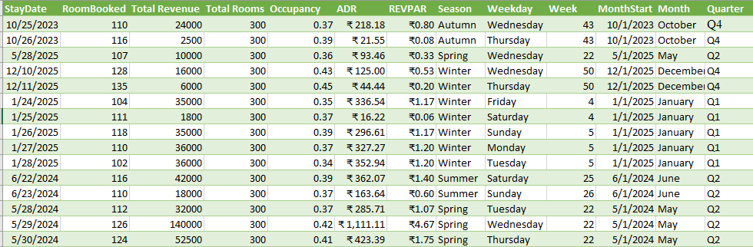

- Power BI Data Modelling
3.1 importing Data to PowerBI
Open Power BI Desktop, go to Home → Get Data → Excel Workbook, select the Excel file, choose the required tables (Booking_Details, Rooms Booked, TBI_Rates, TBI_Bookings, TBI_Calculations) in the Navigator, and click Load to import them.
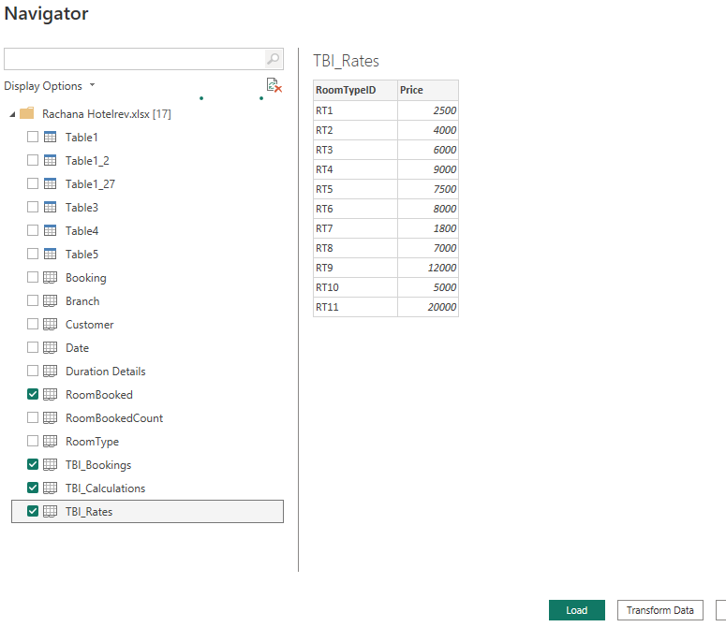
Enhancing Booking_Details (Calculated Columns)
- Go to the Data View (Table icon on the left).
- Select the Booking_Details table.
- Click New Column
- Formula:
MonthStart = DATE(YEAR([StayDate]), MONTH([StayDate]), 1)
- Create Columns in the same process for:

- MonthYear = FORMAT([StayDate], "MMM YYYY")
- Year = YEAR([StayDate])
- Month = FORMAT([StayDate], "MMMM")

- Season = SWITCH( TRUE(), MONTH([StayDate]) IN {12,1,2}, "Winter",
MONTH([StayDate]) IN {3,4,5}, "Spring",
MONTH([StayDate]) IN {6,7,8}, "Summer",
MONTH([StayDate]) IN {9,10,11}, "Autumn" )

- Weekday = FORMAT([StayDate], "dddd")
- WeekNum = WEEKNUM([StayDate].[Date])

- WeekStart = [StayDate] - WEEKDAY([StayDate].[Date]) + 1

- YearWeek = VAR SundayOfWeek = [StayDate] - WEEKDAY([StayDate], 1) VAR ISOYear = YEAR(SundayOfWeek) VAR ISOWeek = WEEKNUM(SundayOfWeek, 1) RETURN ISOYear & "-W" & FORMAT(ISOWeek, "00")
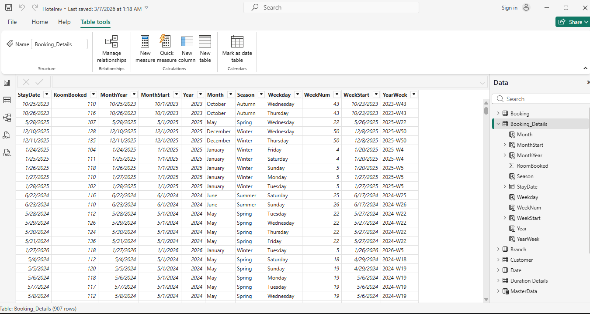
3.3 Creating the MasterData Table (DAX Calculated Table)
- Go to the Modeling tab $→$ click New Table.
- Paste this formula:
MasterData =
VAR CalendarTable =
ADDCOLUMNS (
CALENDAR(DATE(2023,9,1), DATE(2026,2,18)),
"MonthStart", EOMONTH([Date], -1) + 1,
"Month", FORMAT(EOMONTH([Date], -1) + 1, "dd-mmm-yy"),
"DayCount", DAY(EOMONTH([Date], 0)),
"RoomAvailableCount", DAY(EOMONTH([Date], 0)) * 300
)
RETURN
ADDCOLUMNS (
SUMMARIZE (
CalendarTable,
[MonthStart], [Month], [DayCount], [RoomAvailableCount]
),
"RoomSoldCount",
CALCULATE (
SUM (Booking_Details[RoomBooked]),
TREATAS ( { [MonthStart] }, Booking_Details[MonthStart] )
),
"Occupancy %",
DIVIDE (
CALCULATE (
SUM (Booking_Details[RoomBooked]),
TREATAS ( { [MonthStart] }, Booking_Details[MonthStart] )
),
[RoomAvailableCount],
0
)
)
This will create column MonthStart,Month,Daycount,RoomAvailableCount,Roomsoldcount,Occupancy.
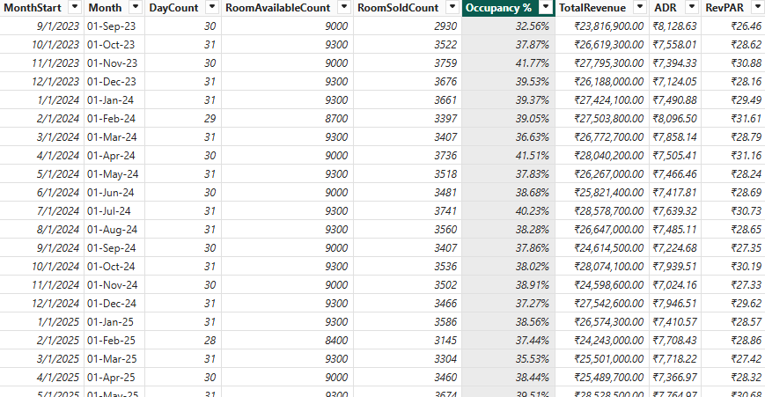

- Create new columns like TotalRevenue,ADR,REVPAR in master Data Table
Formula:
TotalRevenue = CALCULATE(
SUM(Bookings[Revenue]),
FILTER(Bookings, Bookings[MonthStart] = MasterData[MonthStart])
)
TotalRevenue:
Calculates the total revenue generated from bookings for a specific month by summing the Revenue column based on the matching MonthStart.
ADR = DIVIDE(
[TotalRevenue],
MasterData[RoomSoldCount]
)
ADR (Average Daily Rate):
Measures the average revenue earned per sold room, calculated by dividing TotalRevenue by the number of rooms sold.
RevPAR = [ADR] * DIVIDE(MasterData[Occupancy %], 100)
RevPAR (Revenue Per Available Room):
Indicates the revenue generated per available room, calculated by multiplying ADR with the occupancy rate.
- Click on New Measure and create the following measures:
DAX MEASURES:

  - MADR =
DIVIDE(
SUM(Booking[Revenue]),
SUM(Booking[RoomNightSold]))
  - MRevPAR =
DIVIDE(
SUM(Booking[Revenue]),
SUM(MasterData[RoomAvailableCount]))
  - MOccupancy % =
DIVIDE(
SUM(Booking[RoomNightSold]),
SUM(MasterData[RoomAvailableCount]),
0
) * 100
  - MonthlyADR =
MonthlyADR =
CALCULATE(
DIVIDE(SUM(Booking[Revenue]), SUM(MasterData[RoomSoldCount])),
ALLEXCEPT(MasterData, MasterData[MonthStart])
)
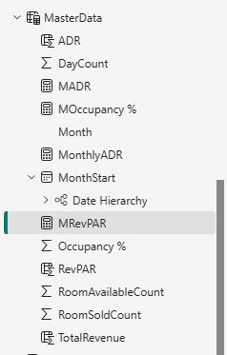
3.4 Enhancing Tbl_Calculation table
- Go to the Modeling tab $→$ click New Measure.
- Create the following measures:
ADR YY Change =
DIVIDE(
[ADR] - CALCULATE([ADR], SAMEPERIODLASTYEAR('TBI_Calculations'[StayDate])),
CALCULATE([ADR], SAMEPERIODLASTYEAR('TBI_Calculations'[ [StayDate].[Date]))
)

MWeek = WEEKNUM(SELECTEDVALUE(TBI_Calculations[StayDate]), 2)

Occupancy % Last Month = CALCULATE([MOccupancy %], PREVIOUSMONTH(TBI_Calculations[ [StayDate]))

RevPAR YY Change =
DIVIDE(
[RevPAR] - CALCULATE([RevPAR], SAMEPERIODLASTYEAR(TBI_Calculations[StayDate])),
CALCULATE([RevPAR], SAMEPERIODLASTYEAR(TBI_Calculations[StayDate]))
)
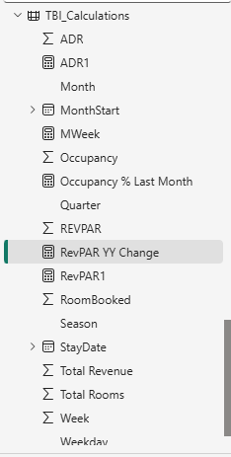
3.5 Creation of Monthly Bookings Table
- Go to the Modeling tab $→$ click New Table.
- Formula:
MonthlyBookings =
SUMMARIZE (
Booking_Details,
Booking_Details[MonthStart],
"TotalRoomsBooked", SUM(Booking_Details[Room Booked])
)
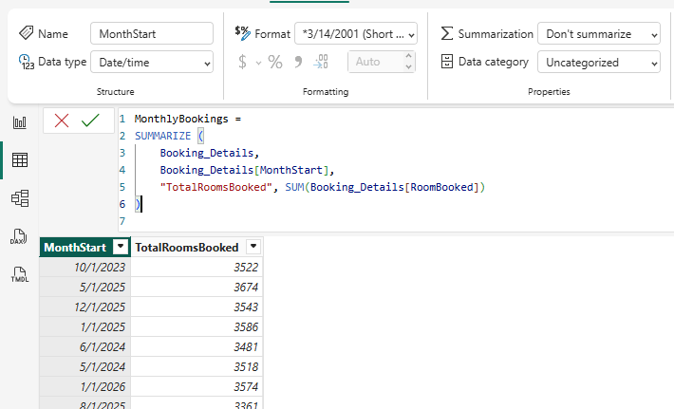
4. PowerBI Visuals:
Visual 1: Summary Table
- Select Visual: Click the Table icon.
- Add Columns: Drag the following fields in this order:
  - MonthStart
  - RoomAvailableCount (Set to Sum)
  - RoomSoldCount (Set to Sum)
  - TotalRevenue (Set to Sum)
  - ADR (Set to Average)
  - Occupancy % (Set to Average)
  - RevPAR (Set to Average)
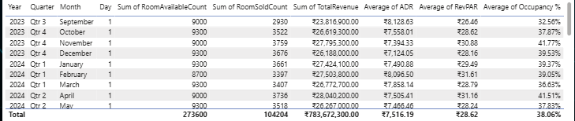

Visual 2: Line Chart
- Select Visual: Click the Line Chart icon.
- X-Axis: Drag MonthStart from the MasterData table.
- Y-Axis: Drag the following three fields:
  - ADR (Set to Average)
  - Occupancy % (Set to Average)
Secondary Y-Axis: RevPAR (Set to Average)
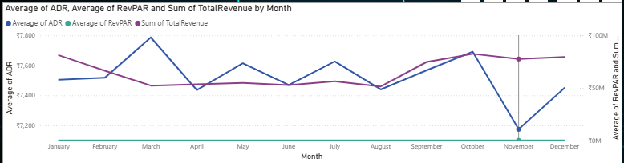Visual 3: KPI Cards
- Select Visual: Click the Card visual icon (looks like 123).
- Card 1 (ADR):
  - Drag ADR from Tbl_Calculation (or your Measure table) to Fields.
  - Ensure aggregation is set to Average (Click dropdown arrow > Average).
  - Format: General > Title > "Average of ADR". Callout Value > Display units > Auto (shows ₹10.00K).
- Card 2 (RevPAR):
  - Copy/Paste Card 1.
  - Replace field with RevPAR. Set aggregation to Average.
- Card 3 (Occupancy):
  - Copy/Paste Card 1.
  - Replace field with Occupancy %. Set aggregation to Average.

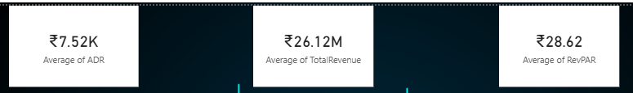
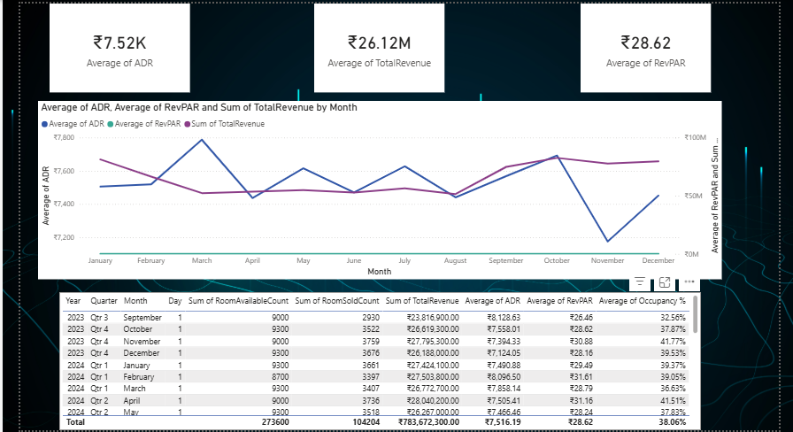
Visual 4: Daily Performance
- Select Visual: Click the Line Chart icon.
- X-Axis: Drag Year from MasterData.
- Y-Axis (Left Scale):
  - Drag ADR (Set to Sum )
  - Drag RevPAR (Set to Sum).
- Secondary Y-Axis (Right Scale):
  - Drag Occupancy % (Set to Average).
- Go to Format (Paintbrush Icon) -> General -> Title -> Enter “Daily Performance”
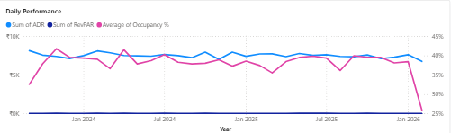
Visual 5: Weekly Performance

- Select Visual: Click the Line Chart icon.
- X-Axis: Drag Week from MasterData.
- Y-Axis: Drag ADR (Average) and RevPAR (Sum).
- Secondary Y-Axis: Drag Occupancy % (Average).
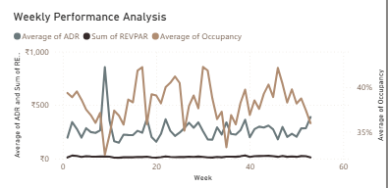
Visual 6: Seasonal Performance
- Select Visual: Click the Line Chart icon.
- X-Axis: Create a hierarchy or drag fields in this order:
  - StayDate ( Year, Quarter from Tbl_Calculation)
  - Season (from Tbl_Calculation)
- Y-Axis: Drag ADR and RevPAR (Averages from MasterData).
- Secondary Y-Axis: Drag Occupancy % from MasterData (Average).
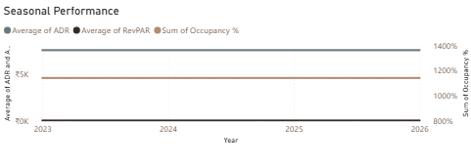
Visual 7: Table
- Select Visual: Click the Table icon
- Rows (The Hierarchy): Drag field into the "Rows"
  - MonthStart from MasterData ( Year, Quarter, Month, Day)
- Values: Drag the metrics you want to measure:
  - ADR (Select Average)
  - Occupancy % (Select Average)
  - RevPAR (Select Average)
- Formatting:
  - Go to Specific Column formatting to apply Currency (₹) to ADR/RevPAR.
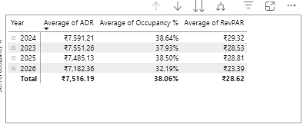
Visual 8: Line Chart
- Select Visual: Line Chart.
- X-Axis: MonthStart from MasterData ( with Year, Quarter, Month, Day).
- Y-Axis: ADR (Avg), RevPAR (Avg), Occupancy % (Avg) from MasterData.
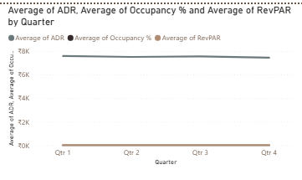

5. Insights – Key Performance Indicator (KPI) Analysis
Based on the aggregated data in KPI cards and summary tables:
- Premium Market Positioning (ADR):
The Average Daily Rate (ADR) is about ₹9,996.68 (~₹10,000). This indicates the hotel operates in the premium/luxury segment with high pricing per room.
- Operational Efficiency (Occupancy %):
The average occupancy rate is 62%, meaning around 38% of rooms remain unsold on average.
- Revenue Reality (RevPAR):
The RevPAR is ₹6,232, which is lower than the ADR. This shows a gap between potential revenue and actual earnings, mainly due to vacant rooms.
6. Conclusion
The analysis shows that the hotel chain has strong pricing power (high ADR) but moderate demand (62% occupancy). Improving occupancy could help reduce revenue loss and increase overall profitability.

